***Type Parameter vs Wildcard***

* ***We can’t use wildcards to define a generic class or interface. Type Parameter should only be used***

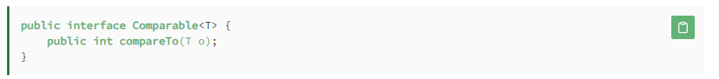

* ***We can’t use wildcards directly to specify the type of a parameter in a method. Type Parameter should be used . we can provide for generic classes used in as parameter (Eg: List<?>)***

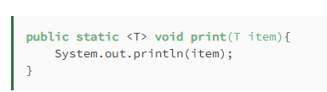

* ***we should consider using wildcards instead of type parameters in Colleections (Majorly in list) to increase flexibility.*** ***If a type parameter appears only once in the method declaration, we should consider replacing it with a wildcard.***

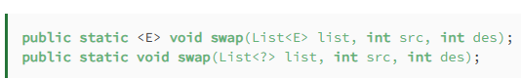

* ***When a generic method returns a generic type, we should use a type parameter instead of a wildcard***

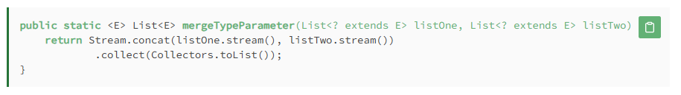

* *Type parameter can be unbounded or upper bounded but cannot be lower bounded*
* *WildCard can be unbounded or upper bounded or lower bounded*
* *Type parameter should be used for multiple bounds*

